# Linux Environment Variable Assignment

1. State the command for the following.
   1. view current environment variables

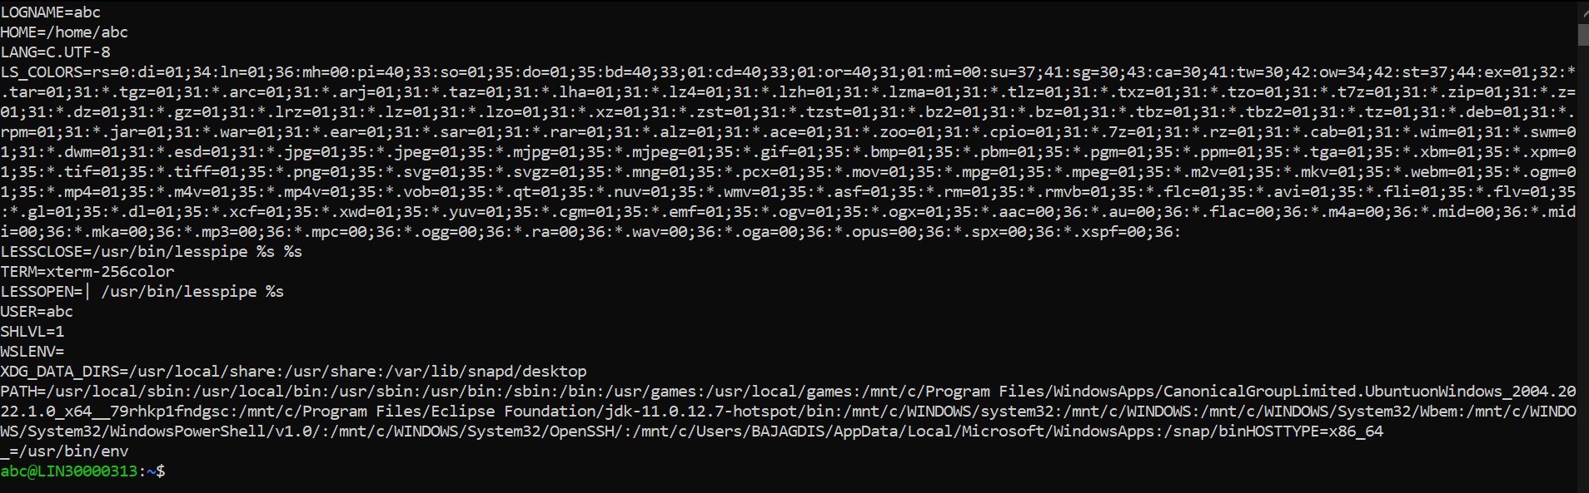

* 1. display the PATH evirnment variable value



* 1. update PATH to include the path to your home directory



1. How will you make the environment changes applicable to all users? Which script is to be modified?
2. I have installed an application named “myapp”. After installation, if I invoke the application, it fails with error as “Command myapp not found”. How will you fix this?